1. Molly, from your middle school is giving an end-of-term party at her place. She invites you to join the party but you are not at the last year of the school, so refuse her invitation kindly and give an excuse saying;

A) I’m afraid I am not coming to the party
B)Sorry but I can’t. I’m busy
C) I’d love to but I can’t make it
D) I will be there at 8 pm

2. Elizabeth: Hey Nick, you are close friends with Jack right?
Nick: Yes, we get on well together.
Elizabeth: - - - - - ?
Nick: Because he keeps my secrets and never tells lies to me.
A) Why does he come to the party
B) Where do you hang out with him
C) Why are you close friends
D) Why do you need him

Kate:What type of music do you prefer listening, Sarah?
Sarah: I like pop music, especially western style.
Kate:What about instrumental,relaxing music?
Sarah: - - - - - .
Kate: I do not like it, either.
3- Which option can be best suitable for the blank in the dialogue?
A) I do not listen to it much
B) Yes, of course, I do
C) Not morethan pop, I think
D)I do not preferwatchingmusicvideos
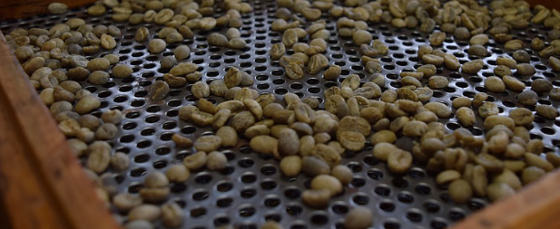
What is Coffee?
A coffee bean is actually a seed. When you dried, roasted and ground, you can use it to make drinkable coffee. If you do not put the seeds in this process, you can plant and it grows into a coffee tree.
You plant the beans, three years later you can have the actual coffee fruit. It is generally cherry-like shape and colour. Then when you wet and dry them, it becomes green. With the roast machine, it gets the color of dark brown so it means it is ready to use in our drinks as coffee and taste delicious flavor.

4-According to thepassage, how can you use the coffee seed if you do not roast, dry or ground?

A)We can enjoy the tasty flovor of the coffee
B)We collect the beans 3 years after we plant them
C)We wet and dry the beans to roast
D) We can plant it and it grows as a coffee tree

5- What is the next step after you collect the coffee fruit?
A)We roast it until it gets brown
B)We make the beans wet and dry them
C)We turn the beans keep from burning
D)When it is ready, we can taste it

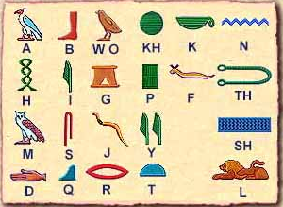

FascinatingFactsaboutHieroglyphics

One of themost amazing old ways of communication was hieroglyphics. People in Egypt used it to contact with and also wanted to put important people’s names on the walls. Normally speaking was the first and most known way of communication but, later, in 4000 BC, Egyptians found the way of written exchanging information.

6-If you want to learn how is your name created in Hieroglyphics, what should you search on search engine?
A)What are different alphabets in Greek language?
B) Where did people first use Hieroglyphics
C)What does a snake Picture mean in Hieroglyphics
D)Which alphabet did Egyptians use?

7-If you want to access your social network account but it says it is a wrong pass word, whatshould you do?
A) I should click on “ I forgot my password” button
B) I should call my friend and ask my password
C) I must find a way to break the password
D) I think I should talk to information technology teacher

Deactivating your account on Twitter will make you stay away from social media and probably you will find more time to share with real friends.

8-Which sentence gives the same idea with the sentence above?

A) If you continue using your Twitter, you will be social
B) If you freeze your account, you will be social in real life
C) If you log off your profile, nobody can see it
D) If you stop usingTwitter,you get bored

Rihanna:Haveyoutriedtouse a compass?
Josh: - - - - -.

9-Which one can be a better answer for the question?
A)Yes, I have. I learned directions like, South, West etc.
B) No, unfortunately not. I don’t know about Falls
C) I have broken one that my friend gave me
D)Yes, I have taken a free running course

Therearemany different places to go and try different sports such as paragliding, skydiving, bungee-jumping, snowboarding etc. Especially in Germany, Zugspitze is the highest and the scariest area to try these sports. People hike there, get ready for the extremest actions to do up in the air or on the top of mountain.

10-What kinds of sports are possible in Germany?
A) Diving, Jumpingout of a plane, Hang-gliding
B) Scuba-diving with sharks, snowboarding
C) Bungee-jumping, hiking, paragliding
D) Hiking, skydiving, skateboarding

